CSA1505 - CLOUD COMPUTING AND BIG DATA ANALYTICS
Experiment-11

11. Create a simple cloud software application for online super market using any Cloud Service Provider to demonstrate SaaS with the template of customer name, address, phone, email, items, quantity etc. with the item classification form.

AIM:
To develop a simple Online Super Market System using Zoho Creator (Cloud Service Provider) to demonstrate the Software as a Service (SaaS) model. The application allows customers to place orders, classify items, calculate the total amount, and manage order details through a cloud-based platform.
PROCEDURE:
- Log in to Zoho Creator.
- Create a new application named Online Super Market.
- Design a form with fields for customer name, address, phone number, email, item classification, item name, quantity, price per item, total amount, order date, and order status.
- Configure the required field types and drop-down values.
- Create a workflow to automatically calculate the total amount, record the order date, and set the order status to Ordered.
- Save and publish the application.
- Enter sample customer and order details to test the application.
- Verify that the total amount and order information are generated correctly
INPUT:
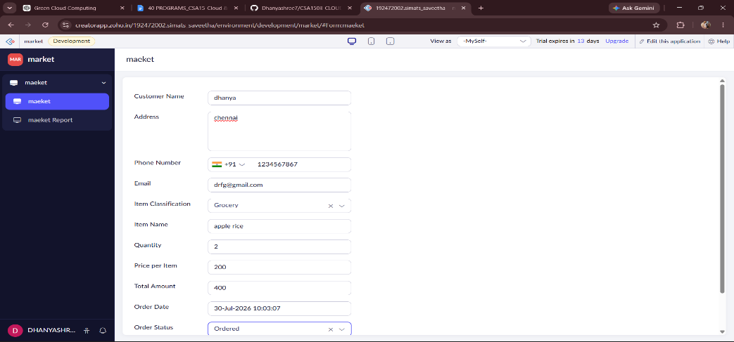
OUTPUT:
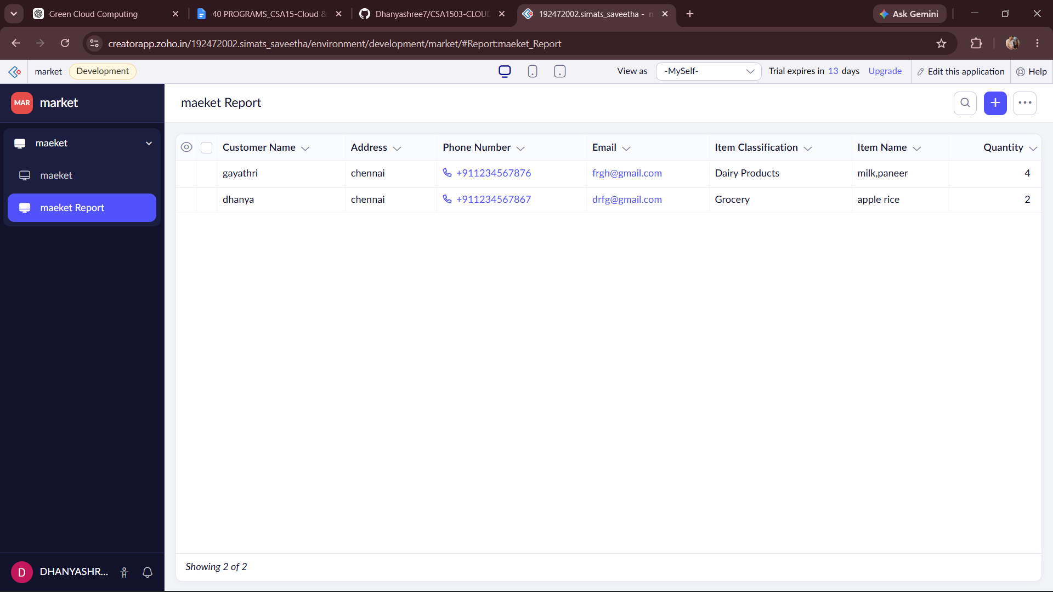
DESIGN:
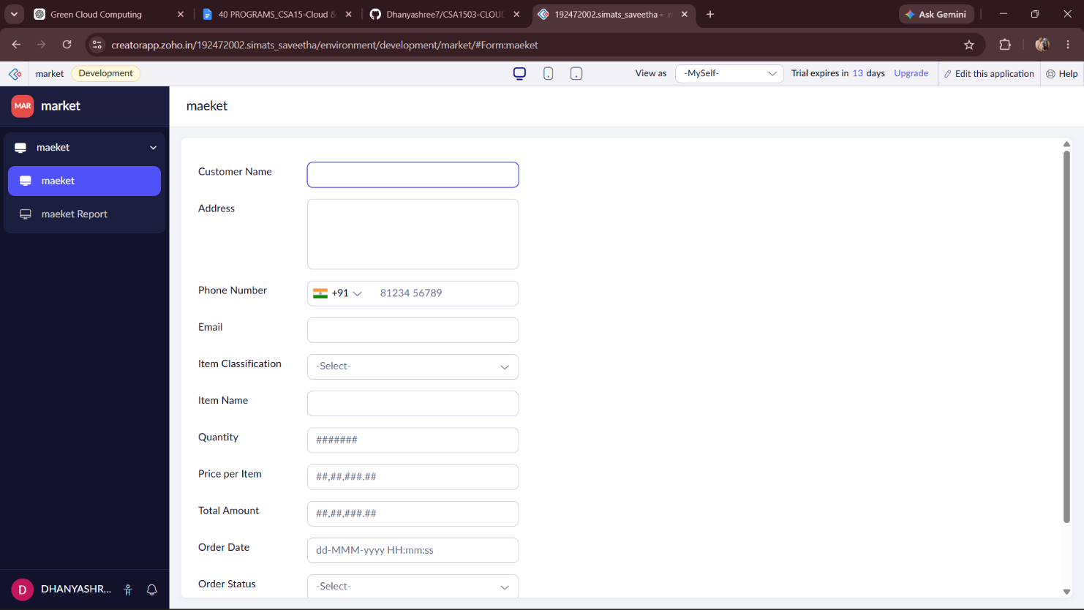
WORKFLOW:
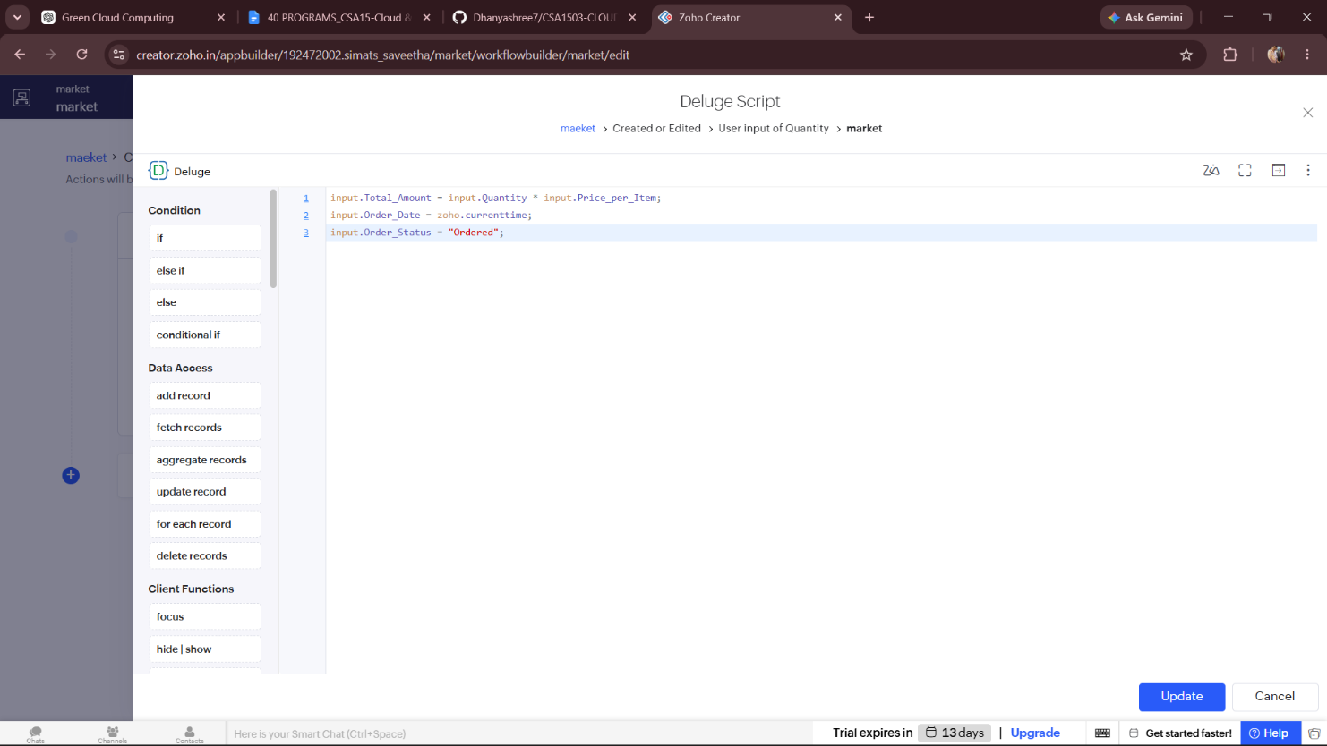
RESULT:
A cloud-based Online Super Market System was successfully developed using Zoho Creator. The application stores customer and order details, classifies items, automatically calculates the total amount, records the order date, and updates the order status. This demonstrates the implementation of the Software as a Service (SaaS) model using a cloud platform.

